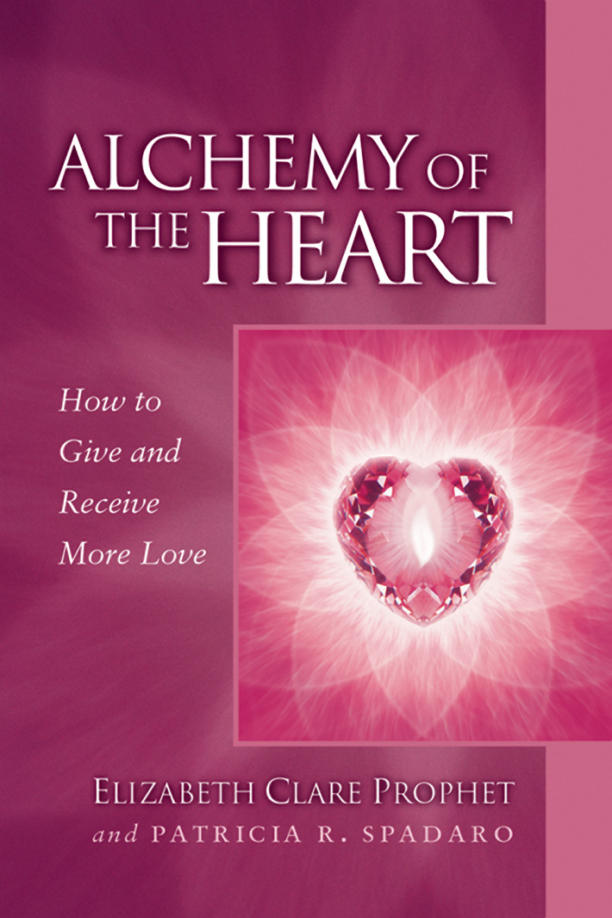
Gain sensitive, profound and rare insights into your heart.
While love can be compassionate and nurturing, it can also be powerful, dynamic and practical
—a catalyst for spiritual growth.

Come be with like-minded people and learn more about
Alchemy of the Heart

Copyright © 2000 Summit Publications, Inc.

Book study starting __________________________
(day, date, time)

__________________________________________
(location name, address)

__________________________________________

For more information contact: __________________________
(name, phone, email)

Bring yourself and a friend!

Discover how the mature heart overcomes hidden blocks to giving and receiving more love. How you can soften and strengthen the heart to create more meaningful relationships in all areas of your life. How even the most intense lessons of love can be the open door to a higher love—and a higher way of loving.

This best-selling pocket guide is available at bookstores and on site. $6.95

