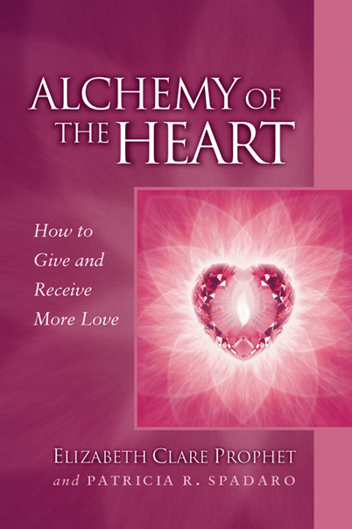
Gain sensitive, profound and rare insights into your heart.
While love can be compassionate and nurturing, it can also be powerful, dynamic and practical
—a catalyst for spiritual growth.

Come be with like-minded people and learn more about
Alchemy of the Heart

Gain sensitive, profound and rare insights into your heart.
While love can be compassionate and nurturing, it can also be powerful, dynamic and practical
—a catalyst for spiritual growth.

Come be with like-minded people and learn more about
Alchemy of the Heart

Book study starting _________________________
(day, date, time)

________________________________________
(location name, address)

________________________________________

For more information contact: _____________________
(name, phone, email)

Bring yourself and a friend!

Book study starting _________________________
(day, date, time)

_________________________________________
(location name, address)

_________________________________________

For more information contact: _____________________
(name, phone, email)

Bring yourself and a friend!
Discover how the mature heart overcomes hidden blocks to giving and receiving more love. How you can soften and strengthen the heart to create more meaningful relationships in all areas of your life. How even the most intense lessons of love can be the open door to a higher love—and a higher way of loving.

Discover how the mature heart overcomes hidden blocks to giving and receiving more love. How you can soften and strengthen the heart to create more meaningful relationships in all areas of your life. How even the most intense lessons of love can be the open door to a higher love—and a higher way of loving.

This best-selling pocket guide is available at bookstores and on site. $6.95

This best-selling pocket guide is available at bookstores and on site. $6.95
95

Copyright © 2000
Summit Publications, Inc.

Copyright © 2000
Summit Publications, Inc.

You have energy centers that act as sending and receiving stations for the energy that flows to you, through you and out from you moment by moment…. Each one has a unique part to play in the process of daily living and spiritual growth.
You have energy centers that act as sending and receiving stations for the energy that flows to you, through you and out from you moment by moment…. Each one has a unique part to play in the process of daily living and spiritual growth.

