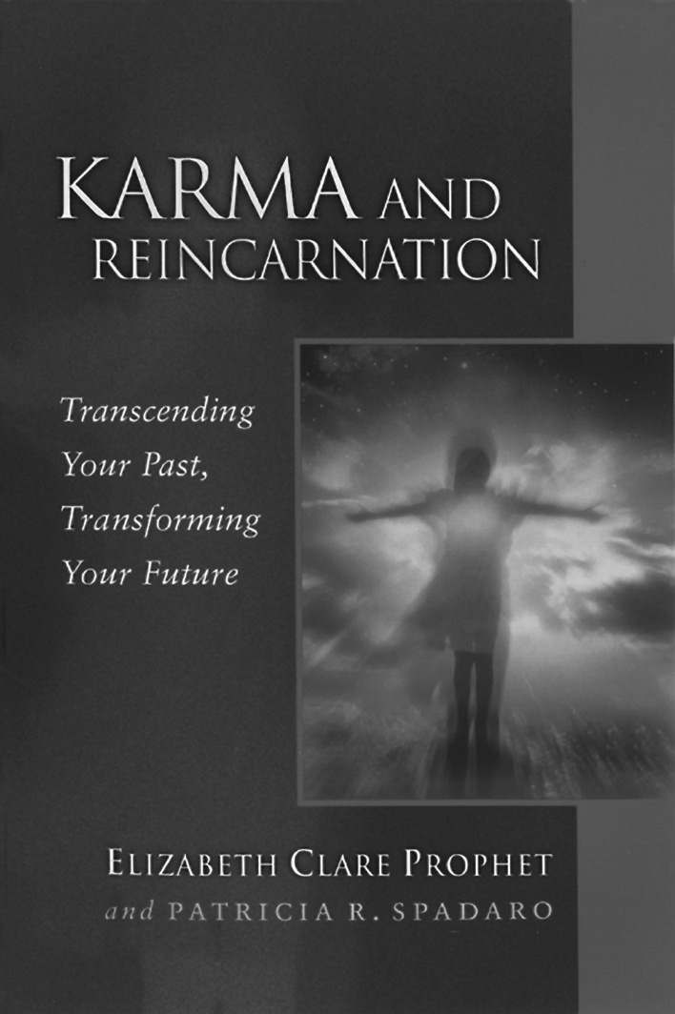
The word karma has made it
into the mainstream.
But not everyone knows what it really means or how to deal with it.

Come be with like-minded people and learn more about

Karma and Reincarnation

Copyright © 2001 Summit Publications, Inc.

Book study starting __________________________
(day, date, time)

__________________________________________
(location name, address)

__________________________________________

For more information contact: __________________________
(name, phone, email)

Bring yourself and a friend!

How do actions from past lives affect which family you’re born into, who you’re attracted to, and why some people put you on edge?
Find out how to turn your karmic encounters into grand opportunities to shape the future that you want!

This best-selling pocket guide is available at bookstores and on site. $6.95

