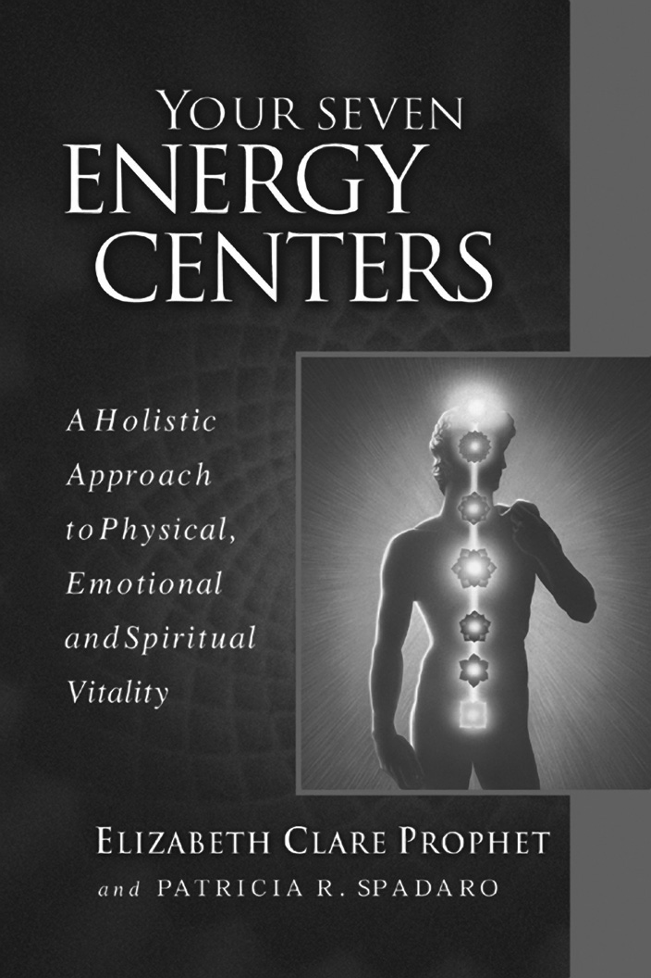

Book study starting __________________________
(day, date, time)

__________________________________________
(location name, address)

__________________________________________

For more information contact: __________________________
(name, phone, email)

Bring yourself and a friend!

Want to find out how your
spiritual anatomy affects your
health, vitality, outlook,
relationships and more?

Come be with like-minded people and learn more about
Your Seven Energy Centers

Copyright © 2000 Summit Publications, Inc.

You have energy centers that act as sending and receiving stations for the energy that flows to you, through you and out from you moment by moment…. Each one has a unique part to play in the process of daily living and spiritual growth.

This best-selling pocket guide is available at bookstores and on site. $6.95

